Develop an application sub system that allows the Managing the Products in a Product Store. You should be able to Add/Update a product details as well as View the product details. Use the File System as your Data store and file path specified in the properties file.

**package** e_com;

**import** java.util.Scanner;

**public** **class** my_ecomm {

**public** **static** **void** main(String[] args)

{

Main a1=**new** Main();

System.***out***.println("Please enter your choice 1 to Add Product,2 to View Product,3 to Update Product");

Scanner sc=**new** Scanner(System.***in***);

**int** n=sc.nextInt();

**if**(n==1)

{

a1.addProduct();

a1.viewProdut();

}

**if**(n==2)

{

a1.viewProdut();

}

**if**(n==3)

{

a1.updateProduct();

}

}

}

**package** e_com;

**import** java.io.File;

**import** java.io.FileNotFoundException;

**import** java.io.FileReader;

**import** java.io.FileWriter;

**import** java.io.IOException;

**import** java.time.LocalTime;

**import** java.util.Properties;

**import** java.util.Scanner;

**interface** Ecommstore

{

**void** addProduct();

**void** viewProdut();

**void** updateProduct();

}

**class** Main **implements** Ecommstore

{

**public** **void** addProduct()

{ LocalTime i;

Scanner sc=**new** Scanner(System.***in***);

System.***out***.println("Enter the ID of the product");

String id=sc.nextLine();

System.***out***.println("Enter the product to be added");

String text=sc.nextLine();

System.***out***.println("Enter the price of the product");

String text1=sc.nextLine();

System.***out***.println("Enter the Quantities to be added ");

String text2=sc.nextLine();

**try**

{

FileReader reader=**new** FileReader("db.properties");

Properties p=**new** Properties();

p.load(reader);

String path=p.getProperty("path");

System.***out***.println(p.getProperty("path"));

FileWriter F1 = **new** FileWriter(path, **true**);

i=java.time.LocalTime.*now*();

F1.write(i.toString());

F1.write("\n");

F1.write(" ID | Product | Price | Quantity | ");

F1.write("\n");

F1.write(" "+id+" "+text+" "+" "+text1+" "+" "+text2+" ");

F1.write("\n");

F1.write("..............................................................................");

F1.write("\n");

System.***out***.println("Data inserted successfully");

F1.close();

} **catch** (IOException e)

{

e.printStackTrace();

}

System.***out***.println("Do u want to add another product if Yes select 1 to view select 2");

**int** n=sc.nextInt();

**if**(n==1) {

addProduct();

}

}

**public** **void** viewProdut()

{

**try**

{

FileReader reader=**new** FileReader("db.properties");

Properties p1=**new** Properties();

**try**

{

p1.load(reader);

} **catch** (IOException e1)

{

e1.printStackTrace();

}

String path=p1.getProperty("path");

FileReader fr = **new** FileReader(path);

**int** i;

**try** {

**while** ((i = fr.read()) != -1)

// Print all the content of a file

System.***out***.print((**char**)i);

} **catch** (IOException e) {

e.printStackTrace();

}

} **catch** (FileNotFoundException e) {

e.printStackTrace();

}

}

**public** **void** updateProduct()

{

FileReader reader = **null**;

**try** {

reader = **new** FileReader("db.properties");

} **catch** (FileNotFoundException e2) {

e2.printStackTrace();

}

Properties p2=**new** Properties();

**try** {

p2.load(reader);

} **catch** (IOException e2) {

e2.printStackTrace();

}

String path=p2.getProperty("path");

String filePath = path;

Scanner sc = **null**;

**try** {

sc = **new** Scanner(**new** File(filePath));

} **catch** (FileNotFoundException e1) {

e1.printStackTrace();

}

StringBuffer buffer = **new** StringBuffer();

**while** (sc.hasNextLine()) {

buffer.append(sc.nextLine()+System.*lineSeparator*());

}

String fileContents = buffer.toString();

System.***out***.println(fileContents);

sc.close();

Scanner update=**new** Scanner(System.***in***);

System.***out***.println("Enter the product name from the list which needs to be changed");

String oldLine = update.nextLine();

System.***out***.println("Enter the new product name to update");

String newLine = update.nextLine();

fileContents = fileContents.replaceAll(oldLine, newLine);

FileWriter writer = **null**;

**try** {

writer = **new** FileWriter(filePath);

} **catch** (IOException e) {

e.printStackTrace();

}

System.***out***.println("");

System.***out***.println("new data: "+fileContents);

**try** {

writer.append(fileContents);

} **catch** (IOException e) {

e.printStackTrace();

}

**try** {

writer.flush();

} **catch** (IOException e) {

e.printStackTrace();

}

}

}

**OUTPUT 1**

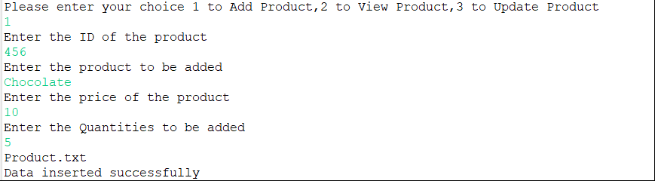

**OUTPUT:2**

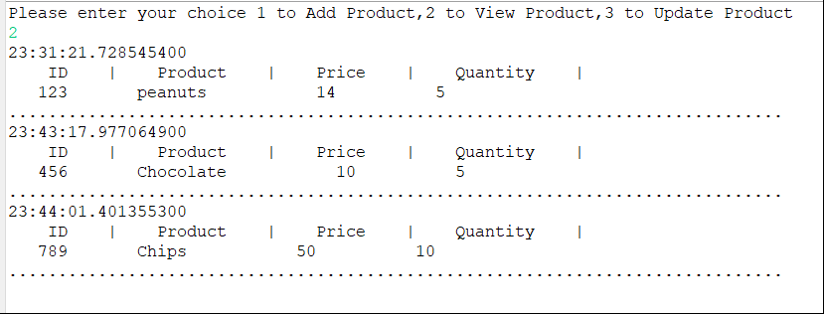

**OUTPUT 3:**

